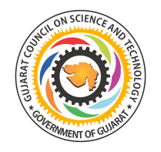
Gujarat Council on Science and Technology, (GUJCOST) Gandhinagar
Sponsored
One Day National Seminar on
“Global Scenario of Pharmacy Education: Challenges and Opportunity”
(February 07, 2015; Saturday)
Organized by
The M L Gandhi Higher Education Society’s
Shri B. M. Shah College of Pharmaceutical Education & Research, Modasa

Registration Form

Name:
Qualifications:
Designation:
Organization:

College Address:

Phone:
Mobile No.:
Email ID:
Registration as (Tick):
Academicians: 300/-

Student: 200/-
Industry Personal: 500/-
Amount: DD No:

Drawn of Bank:
Date: Place:

Date: Signature

