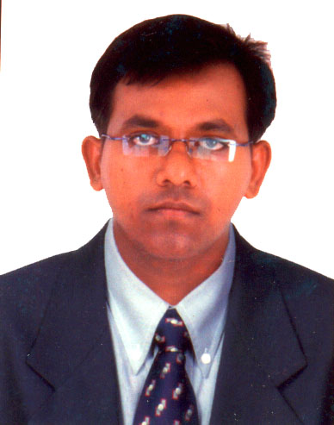

1. Name: Patel Alpeshbhai Dineshbhai

2. Date of Birth: 30-10-1985

3. Educational Qualification: M. Pharm, PhD

4. Work Experience
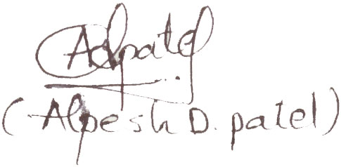
Teaching: 13 year 3 months
• Research: 10 years
• Industry:
• Others

5. Designation : Professor and In charge Principal
6. Area of Specializations: Pharmaceutical Technology, Oral control drug delivery system

7. Subjects teaching at:

Under Graduate Level: Pharmaceutics, Pharmaceutical Engineering – I & II, Biostatistics, Dispensing Pharmacy I & II,
Post Graduate Level: Research Methodology (P.G), Experimental Design

7. Research guidance:
Master’s 13 students doing M. Pharm
Ph. D. Nil

8. Projects carried out:
M. Pharma: Formulation and Optimization of Fast release Rabeprazole Sodium Tablet Using Acid buffer technology.
Ph. D.: Design And Development of Oral Osmotic Drug Delivery System

9. Patents Nil

10. Technology Transfer :Handling of Optimization and Transfer technology of sustained release tablet for Themis Medicare Ltd, Mumbai-400104.

11. Research Publications - National Journals : 20
- International Journals : 13

12. No. of Books published with details : 3

