1. Name: Srushti Yogeshbhai Joshi

2 Date of Brirth: 26-03-1998
3. Educational Qualification: M. Pharm, PhD Persuing
4. Work Experience
Teaching: 1 year 1 months
• Research: -
• Industry: -
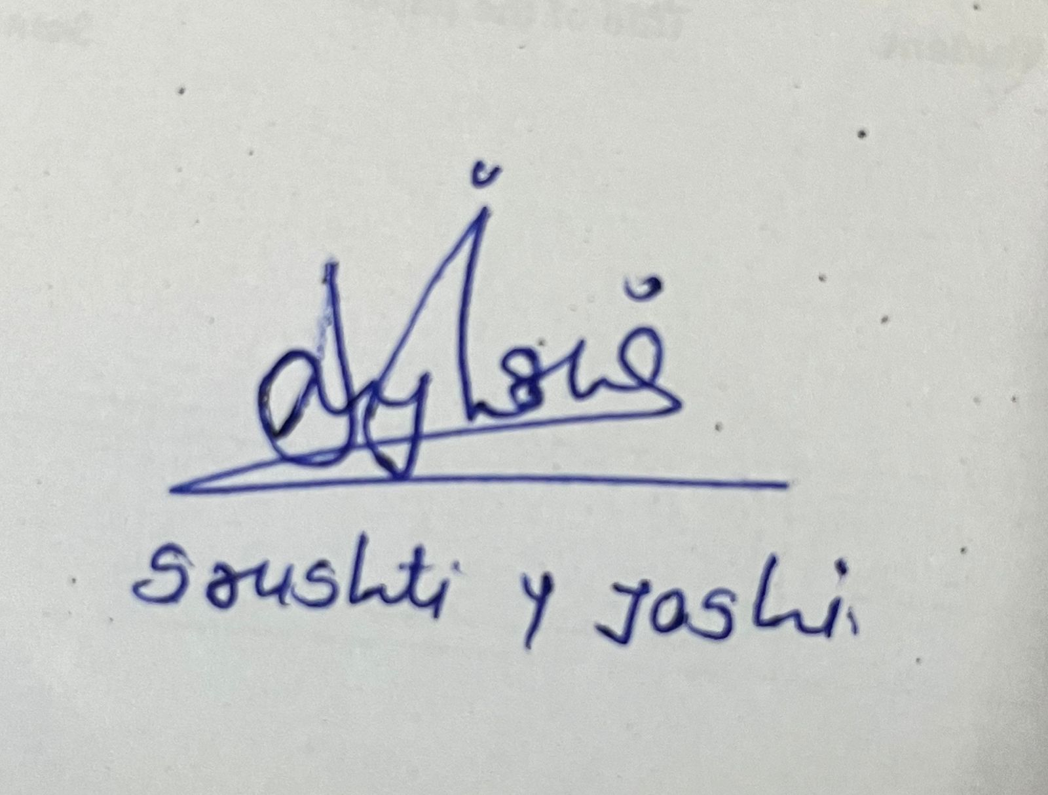
• Others: -

5. Designation : Assistant Professor
6. Area of Specializations: Pharmaceutical Quality Assurance

7. Subjects teaching at:
Under Graduate Level: Pharmaceutical Analysis, Inorganic Chemistry, Communication skills, Biochemistry.

7. Research guidance:
Master’s Nil
Ph. D. Nil

8. Projects carried out:
M. Pharm : Stability Indicating Rp-HPLC method validation for Sunitinib Malate in it’s tablet dosage form.

